Report

Music background

In music a specific set of frequencies called notes are used which follow the sequence CDEFGABC. For example this started at C1 it would end C2 which would have a double the frequency of C1 [1], this is called an octave.

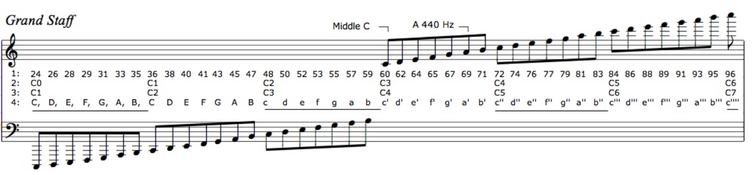

Figure : Diagram showing different musical note notations [1]

The important parts of figure 1 are point 1 is the MIDI numbering and point 3 is the scientific musical notation. These are the notations that will be referred to in this section.

An octave contains 12 notes four of which are sharps/flats each note is 21/12 larger than the previous note this is the reason why in the previous example C1 has half of the frequency of C2 [1]. These two notes are both classed as C’s as they sound similar due to the relationship between the frequencies being a multiple of two.

A limitation of some of the instruments like the panpipes and xylophone is that they have a limited range of notes they can play. Therefore, the range of notes should be chosen to match the song choices. If the range of notes one of these instruments is required to play exceeds the range of the instrument it will sound wrong. For example if the instrument has a range of C1 to E2 and the range of the music is C1 to C3 the instrument would have to revert back to C2 or C1 when trying to play C3 which would sound out of place in relation to the other notes being played. However, if the notes being played were an octave above the range of the instrument it could still be used to play those notes as they would sound similar as long as the number of notes required to play was less than the range of the instrument. For example if an instrument had a range of C1 to E2 and was needed to play notes from the range C2 to E3 it would still work as the notes would sound similar and the number of notes required to be play it is the same.

# Bibliography

|  |  |
| --- | --- |
| [1] | C. O. 2. Jarrod Hart (Los Olivos, "Musical Notes Explaned Simply," theprovincialscientist, 25 October 2011. [Online]. Available: http://theprovincialscientist.com/?p=1576. [Accessed 20 Novemeber 2017]. |
| [2] | "MIDI numbering, the Helmholtz Pitch Notation System,," theoretically correct, [Online]. Available: http://www.theoreticallycorrect.com/Helmholtz-Pitch-Numbering/. [Accessed 20 November 2017]. |
|  |  |
|  |  |
|  |  |
|  |  |
|  |  |
|  |  |
|  |  |